cardinal joint fire district  Is Hiring Part-Time Firefighter/Paramedics  training:  Countless hours of hands-on and classroom training available.  Rotations:  Monthly sign-ups. 12- and 24-hour shifts available.  physical fitness:  exercise room at station.  physicals: annual medical eXam provided.  PAY: Ff/emt = $11.83  Ff2/emt = $13.06  ff2/paramedic = $14.06  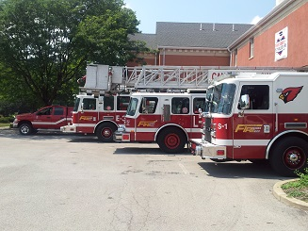 |  |  | 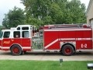  STEP 1: Applications/ Resumes accepted and reviewed  Applications available at Fire Station 2, 7075 Herbert Rd., Canfield, OH 44406 or from Chief Donald Hutchison. dhutchison@cardinaljoint fire.com * 330-533-4316  STEP 2: Reference Check/Interview  STEP 3: Physical Agility Test at Tri-C  STEP 4: Conditional Offer of Employment  Pending background check, physical, and drug screening.  Each step must be passed to proceed.

